Sheridan Dela Cruz
April 18, 2026
Module 5.2
Github Repo: https://github.com/shedzip-wq/csd-310
Run the SQL script:
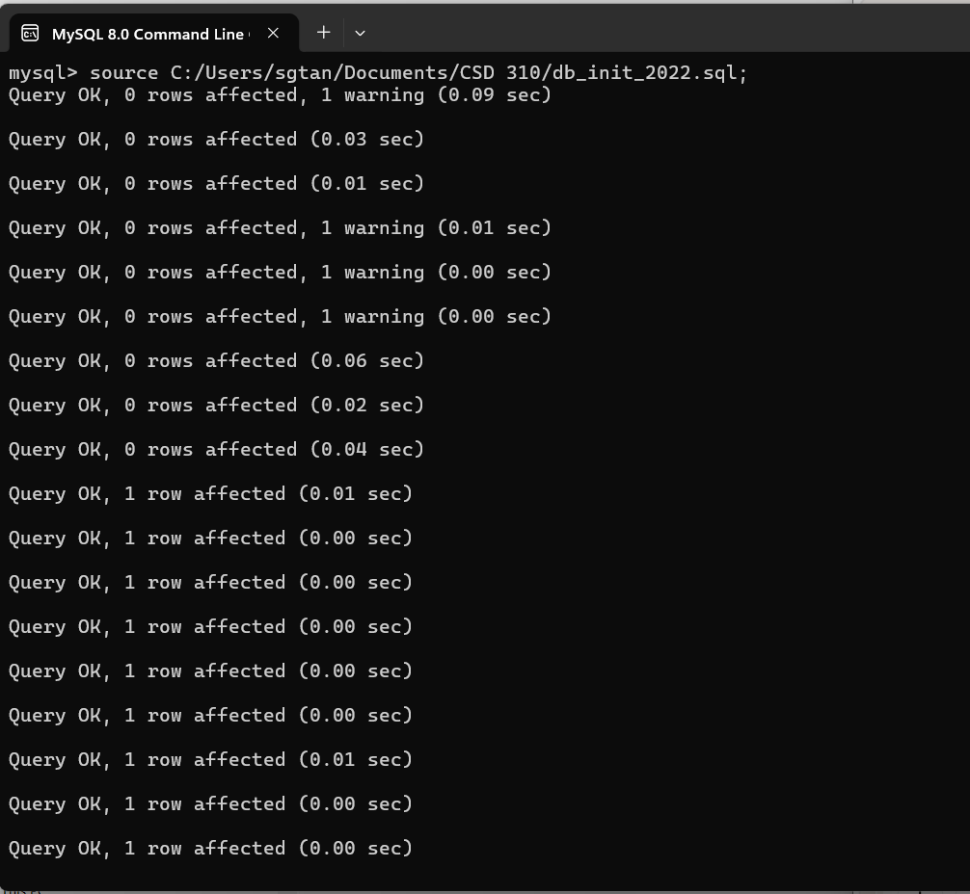

List of Database Tables
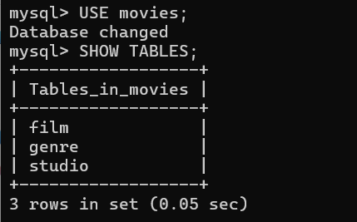
Mysql_test.py script:
